CBA Title Written as a Question
CBA Subtitle giving more detail
[Place an image here]

CBA 1: A Mathemical Investigation
[or]
CBA 2: A Statistical Investigation
[Delete the title you don’t need]

[Template provided by www.TheMathsTutor.ie]
[Check www.themathstutor.ie/cbahub for
more useful CBA and Assessment Task resources]

[NOTE: The instructions for each section of this document are in blue font and contained in square brackets.
You can fill in each section and then delete the instructions.
OR print off the template so you have a copy of the instructions, and then get rid of all the instructions, and fill in each section.
You might have to do several passes through your CBA report before you have it finalised]

Table of Contents
Table of Contents
Introduction 4
Assumptions 5
Method 6
Results 6
Results and Discussion of Data 10
Conclusion 11
CBA 2 Reflection 12
References 12
Appendices 14

[The above table of contents needs to be updated at the end once all edits are completed. Google how to do this if you are not sure. If you prefer not to use automatic table of contents, you can create it manually, one line at a time.]
[The table of contents should be the first thing that the reader sees after the cover page in a CBA report/investigation. A good table of contents should be easy to follow. All titles/headings should be listed in order and page numbers should be included. The reader should be able to look at your table of contents and understand immediately how your CBA project is organised. Make sure to go back and review your table of contents at the very end of the investigation to ensure that everything is on the correct page etc. ]

Introduction
[The introduction to your CBA is a chance for you to capture the reader’s attention and to give them a clear idea of what you will be talking about throughout the project. Refer to the title of your project. We recommend that your title should be in the form of a question so the aim of this project is to answer your own question at the end. The more you refer back to your title question, the clearer your project content will be to your reader.
Here are some tips for organising your introduction:
- Start the introduction by stating the title of your project and what area of Mathematics it relates to.

For example, if you are writing a report about how much it will cost to give your bedroom a makeover. In this case you should start the introduction by stating the title “How much will it cost me in euro to give my bedroom a makeover?” and indicating that this project will use Arithmetic, Area & Volume and Statistics to answer this question.

- Next, you should narrow down the introduction to talk more specifically about the topic you are investigating, and why you chose this topic.

In the example above, the following introduction could be used:
“I chose this project as I have a keen interest in the area of interior design and I enjoy working with money. This project also overlaps with Business Studies which is another one of my favourite subjects. I have wanted to give my bedroom a makeover for a while now and I think this project is the perfect opportunity to give me an insight as to what is involved and the cost etc.”

- Finally, you should predict what the outcome of your project is going to be based on what you know about it already. You can then compare your predicted outcome with the actual outcome at the end of the project.]

[Use the materials from www.themathstutor.ie/cbahub, in particular the “Features of Quality” for CBA 1 or CBA 2 as needed, and you can also use the example CBAs for guidance]

Assumptions

[Use the materials from www.themathstutor.ie/cbahub, in particular the “Features of Quality” for CBA 1 or CBA 2 as needed, and you can also use the example CBAs for guidance]

[You should make at least 2 or 3 assumptions based on what you reasonably believe you already know. These assumptions ideally should be put in bullet form.

The following assumptions could be used for the bedroom makeover:
- I am assuming that I can afford everything within €900 because I will buy everything at the best rate possible
- I am assuming that I will carry out this project during mid-term which will allow me to work on it for approx. 6 hours every day
- I am assuming that I will have help to assemble new furniture from my Mum as she has agreed to help with this part
- I am assuming that each piece of furniture that I may purchase will take no longer than 40 minutes to assemble with help (guidance from the XXX furniture retailer’s manual)
- I am assuming that can let the walls dry overnight and not during the day to maximise my time available to work in the bedroom (letting them dry during the day means that I will not have access to the bedroom)
- I am assuming that I will get 25% off the cost of paint as there is a sale on in XXX paint shop at the minute
- I am assuming that I will be doing all of the work (except assembling furniture) by myself which will cut back on the cost of hiring someone to carry out the work]

Method
[Use the materials from www.themathstutor.ie/cbahub, in particular the “Features of Quality” for CBA 1 or CBA 2 as needed, and you can also use the example CBAs for guidance]

[The method contains the steps that you took to complete your investigation. This is your procedure and should be written in the past tense. Your methods section should contain enough detail so that another student could read this section and successfully duplicate your method. Write the methods section as if you were giving direction for someone else to carry out this section. Use the following guidelines when writing your method:
- Use instructional language instead of narrative language
- Keep the method very simple and factual so that it does not become overwhelming
- Use past tense
- Number the steps in your method
- Write out the steps of the method in chronological order so that it is clear for the reader
- Do not include any results in this section – just include what you did to complete the task
- Mathematical equations / statistical steps should be described
- Describe any materials or equipment used

For the bedroom makeover, the following method could be used:
- I measured the length and width of the bedroom using a measuring tape and recorded my results in metres
- I measured the height of the bedroom from the floor to the ceiling using a measuring tape and recorded my results in metres
- I decided that I would purchase a new bed, wardrobe and chest of drawers for the room.
- I ensured that these items would fit in the room by double checking the measurements (length, width and height) online in metres.
- I looked up different prices for these items on XXX and YYY retailer websites.
- I then compared the prices to see which was cheapest………….etc.

You can see from above that the method is a clear and concise set of instructions. The simpler the method the easier it is to follow!]

Results
[Use the materials from www.themathstutor.ie/cbahub, in particular the “Features of Quality” for CBA 1 or CBA 2 as needed, and you can also use the example CBAs for guidance]

[The results section contains raw data (i.e. no analysis or discussion of results). Results may be presented in text and visual form. The more visual representations used here the better (within reason). Visuals such as bar charts, pie charts, diagrams with measurements, tables and photographs can be used. You should explain what each visual means with a paragraph of text. It’s important to choose the appropriate visual representations that are optimal for showing the results.

It is vital that you include the correct units of measurement. Tables can be very useful when handling large amounts of data and visual representations can capture trends and developments which may not be as obvious from a table. Label all charts, tables and visuals. You can draw/design visuals by hand or you can use software such as Microsoft Excel or Google Sheets etc. In any case, make sure to label everything correctly.

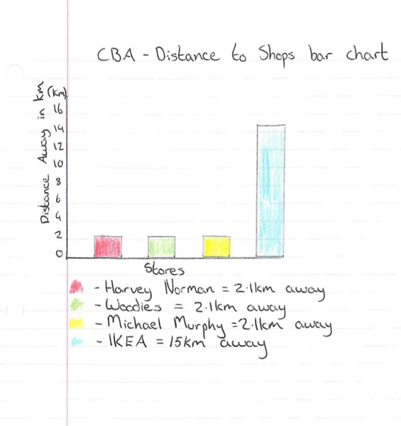
Here are some examples of tables, diagrams and charts both by hand and using Excel. Some of these are sourced from example CBAs from the NCCA]
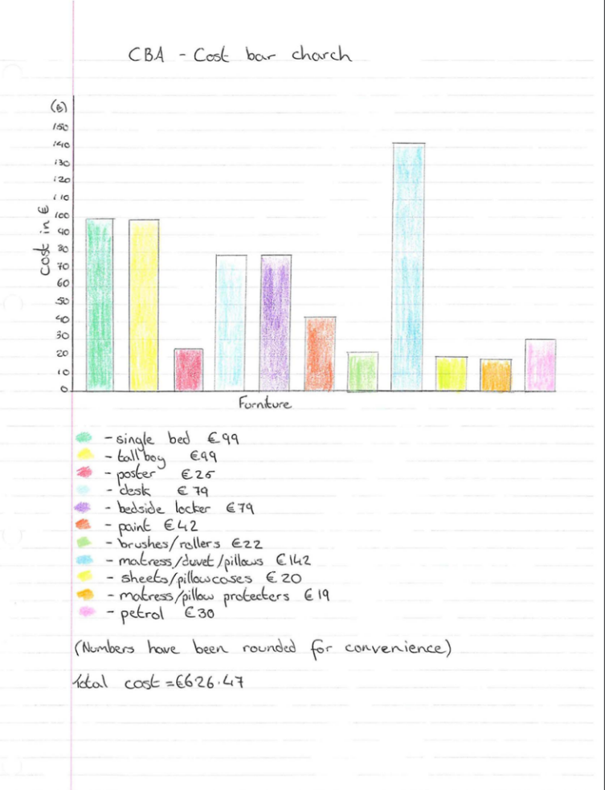

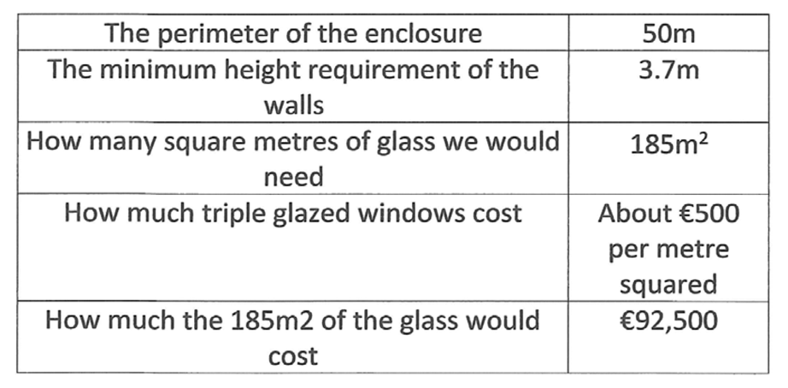
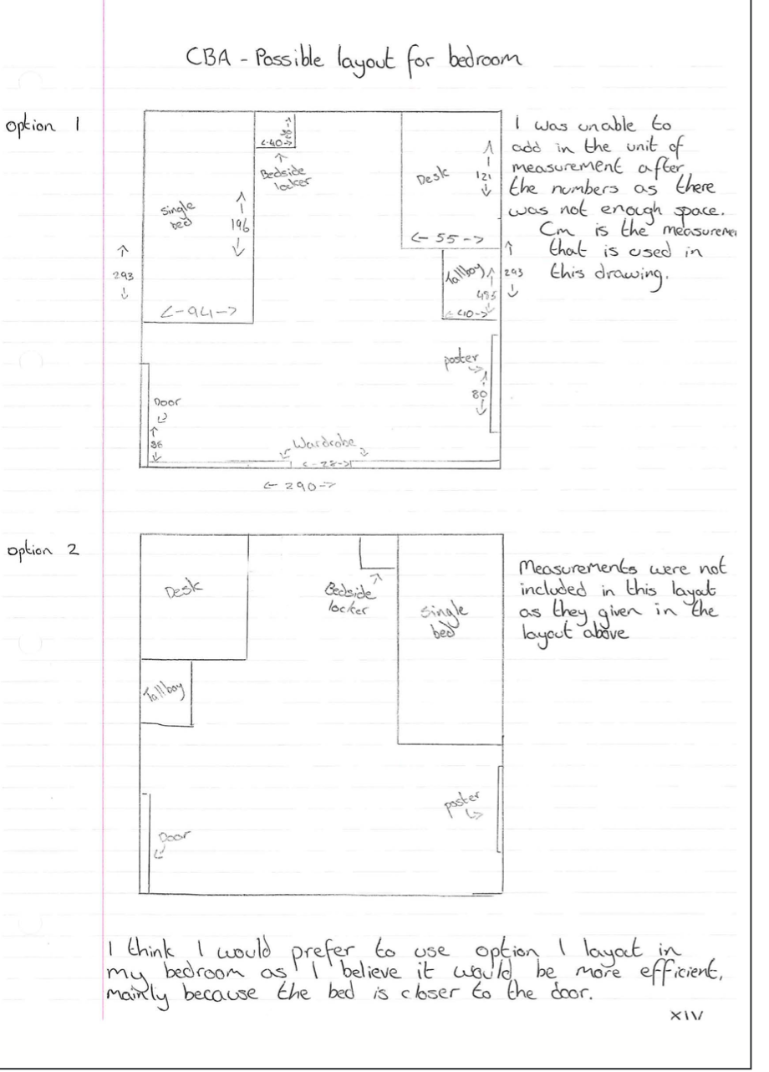
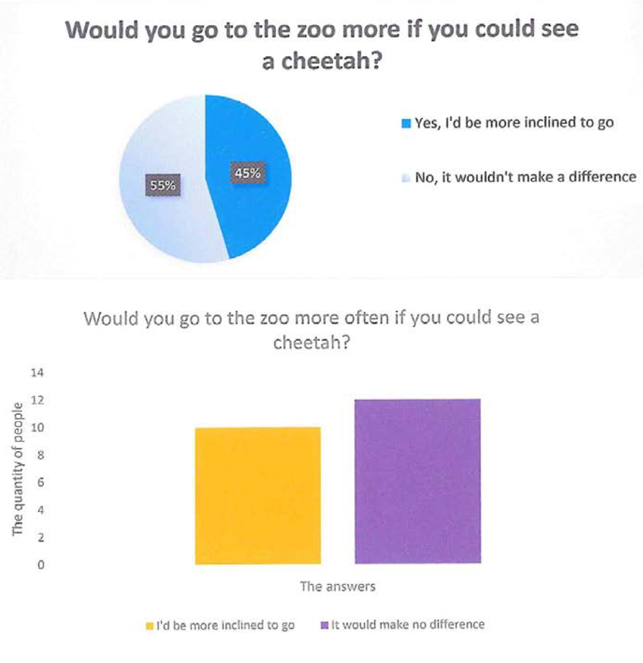

[Delete the charts and tables above]

Results and Discussion of Data
[Use the materials from www.themathstutor.ie/cbahub, in particular the “Features of Quality” for CBA 1 or CBA 2 as needed, and you can also use the example CBAs for guidance]

[The discussion should start with a statement to indicate whether the findings in the results section support expected findings (see introduction). This is a chance for you as the student to demonstrate your understanding of your own work. When doing this, keep referring back to your data/results.
The discussion section of your CBA should explain the significance/meaning of the results and data to the reader. The discussion should give a detailed account of what happened and an evaluation of what happened. It is very important to note that if your results contained errors or mistakes, you must acknowledge and explain the reason for these errors. Try and refer to specific calculations/tables/charts/diagrams if possible.
You may consider the following steps when writing your discussion:
- State, in a few sentences, whether results from your CBA match with your predictions for the outcome based on your assumptions. Don’t forget to answer your own question (i.e. the CBA title)
- Make sure to include a section in which you refer directly to your data/results that led to your outcome. It would be helpful to also refer to your visual representations as evidence to support your outcome
- Add in a paragraph about your understanding about what your result means and how it relates back to the specific Mathematical concept
- Discuss what went well, what didn’t go so well and what you change if you were to repeat the CBA again. Did any unusual results crop up? If so, try and explain these results
- Finally, refer back to your original question and state the significance or implications of your findings and make a recommendation for future investigations in this area

e.g. “Overall, it cost me €950 to give my bedroom a complete makeover. As the budget was €900, this means that I went €50 over the limit. This was due to buying a very expensive wardrobe for the room. If I were to complete this project again, I would carry out more research in relation to pricing furniture to ensure this wouldn’t happen again.”
A good discussion can take the following format, so keep this in mind when writing your discussion:
- Restate
- Explain
- Results
- Uncertainties
- New questions or discoveries
A good way of remembering this is to memorise the word “RERUN”]

Conclusion
[Use the materials from www.themathstutor.ie/cbahub, in particular the “Features of Quality” for CBA 1 or CBA 2 as needed, and you can also use the example CBAs for guidance]
[A good quality conclusion paragraph should contain the following:
- Answers your CBA question as stated in your title.
- Sums up the findings in a clear and concise manner
- Communicates the significance of the findings
- Helps the reader to take note of any unforeseen results in your CBA
- Restates the answer to your question in a clear and concise manner

It is important that you do not go back into an extensive discussion when completing this section. The main aim for this section of the CBA is to sum up your findings and conclude the project. An example of a good Mathematical conclusion would be:

“I investigated how much money in euro would it cost to give my bedroom a makeover. I had a budget of €900 and I predicted that I would stay within this budget. The results of this investigation indicated that it would cost me €950, so the results did not support my prediction. There was a 5.6% error in my prediction. The makeover cost more money due to the choice of furniture. If I were to repeat this CBA, I would research cheaper furniture options”.]

CBA 2 Reflection
[Use the materials from www.themathstutor.ie/cbahub, in particular the “Features of Quality” for CBA 1 or CBA 2 as needed, and you can also use the example CBAs for guidance]

[This section of the CBA is very important and will help determine what grade you get. It is important to make a note of what went well and what did not go so well during the project. You may ask yourself the following questions when writing your reflection:
- What new skills did you learn when completing the CBA?
- Did you run into any problems when carrying out the CBA and how did you overcome these?
- How good was your time management?
- What level of effort did you put in? Discuss.
- What did you enjoy/learn from this CBA?

Below is an example of a CBA Self-Reflection taken from the curriculumonline.ie website. This student completed the CBA 1 and wrote this self-reflection at the end of the project:]
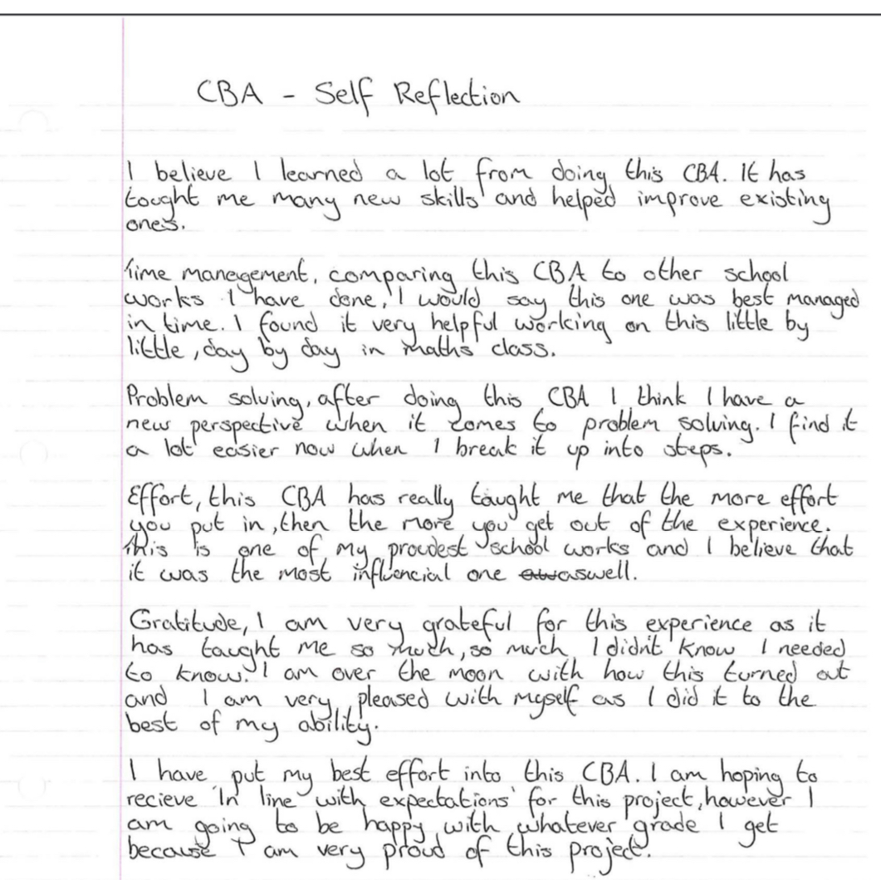
[Delete the image above]

References
[Use the materials from www.themathstutor.ie/cbahub, in particular the “Features of Quality” for CBA 1 or CBA 2 as needed, and you can also use the example CBAs for guidance]

[At the very end of the CBA, you should provide a complete list of references from your entire CBA project. This includes page numbers of textbooks, reputable websites, journal articles etc. It is very important that you get your information from reliable sources. This means looking up reliable and reputable websites such as the Central Statistics Office (www.cso.ie), the HSE website (www.hse.ie) etc. Government websites and commercial websites can be used as references

Try to avoid websites where information is based on opinions from non-experts. Remember that you are looking for factual and reliable information to assist you with your investigation. Keep a record as you go along of any books, websites etc that you use throughout your project.]

Appendices
[Use the materials from www.themathstutor.ie/cbahub, in particular the “Features of Quality” for CBA 1 or CBA 2 as needed, and you can also use the example CBAs for guidance]

[The appendices contain extra material that is not an essential part of the CBA itself but may be helpful to the reader in helping to provide a better understanding of the CBA problem. For example this material may contain too much detail to be included in the body of the investigation so any “extra” material should be included as an appendix here. This material should be clearly labelled, and you can make reference to appendix material if need be when writing other sections of your report.]

